**IsDB-BISEW**

Islamic Development Bank

Bangladesh Islamic Solidarity Educational Wakf.

E/8-A, Rokeya Sharani, Sher-e-Bangla Nagar,

Dhaka, Bangladesh 1207

**4-Year Diploma Scholarship Programme**

Web Application Development using C#

**WADA/USSL-M/54/01**

SQL Server Project

**Project Case Study**

Salary Management System (SMS)

**Submitted by**

Md. Rafi Siddique

Trainee ID: 1273013

**Exam Control System**

**Introduction:** Presently, if a teacher conducts any examination, they have to manage the whole Exam system manually which is time-consuming. But with an Exam Control System teacher can manage all things like Exam Schedule, Teacher’s invigilation Schedule, Student’s seat plan, and also store student’s exam result. It will be easy and accurate to manage the exam details and student results.

There are Some advantages factors of this system which are given below:

1. Exam Control System reduces the time managing the details.
2. It tracks all information of Students.
3. Manage the information of Students.
4. To increase the efficiency of managing the Examination, Students.
5. Manage the information of the Examination.
6. Editing, adding, and updating Records is improved, resulting in proper resource management of Examination data.

**Main Function:**

Database Schema:

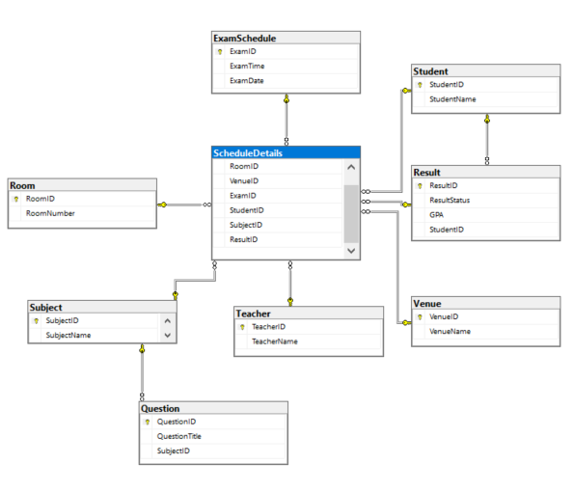

Function:

* Add Exam Date, time, Venue, Room number, Subject, etc.
* Add Teacher and Student Details.
* Manage all Details.
* Show Student Result in Detail.
* Can show Student Exam Schedule Details.
* Add Questions for the Exam.
* Can track all information.
* Provides Search facilities.
* Can show all information as a report.
* You can print Exam Schedule and Teacher’s Invigilator Schedule.

**Advantages:**

* Help to manage all data of Exams.
* Reduce administrative work.
* Saves time and improves performance at work.
* Increase accuracy in Data management.
* Student can get their result fast.
* Students can see their Exam Schedule and Results online.

**Objective:** The main objective of the Exam Control System is to manage the details of the Examination, Students, Exam Results, and Course.

Functionalities provided by Examination Control System are as follows:

It provides searching facilities based on various factors. Such as Exam, Result, and Subject. The Exam Control System also manages the Exam Schedule, Teacher Schedule, Student results, and Seat Plan.